Research of Polymers: Polyurethane

* History：

Polyurethane (PU) was invented in 1930s by Professor Dr. Otto Bayer, who is a German industrial chemist. In World War II, polyurethane was first intentionally used as the replacement for the rubber which was expensive and hard to obtain. During the war period, other applications of polyurethane were developed quickly, which involving the **impregnation of paper** and the manufacture of mustard gas **resistant garments**, high-gloss **airplane finishes** and chemical and corrosion-resistant **coatings** to protect metal, wood and masonry (American Chemistry Council).

* Synthesis

The reaction of producing the polyurethane need **isocyanates** (who have more than one reactive isocyanate group (-NCO) per molecule such as diisocyanates and polyisocyanates) and **polyols** (who have two or more reactive hydroxyl (-OH) groups per molecule such as diols, triols, polyols) in the presence of suitable catalysts and additives (Lazonby).

The synthesis is a rearrangement reaction: “A hydrogen moves from the alcohol to the nitrogen, while the oxygen links to the carbon” and this leads to the formation of the urethane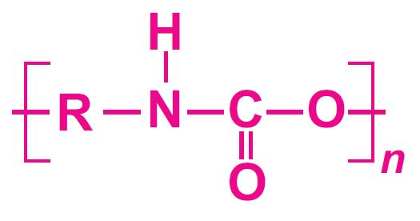 linkage ” (Ohpardt).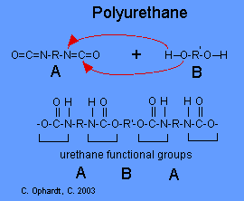

Diagrams: two types of isocyanates: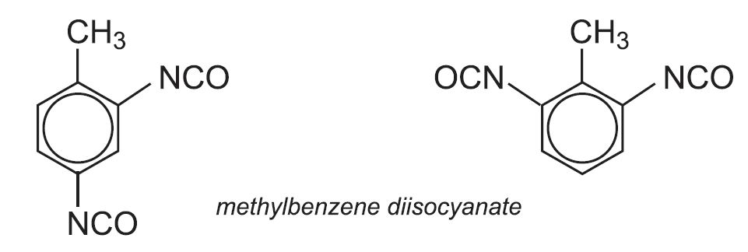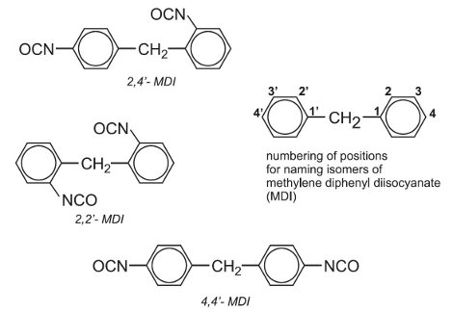

* **TDI** (toluene diisocyanate or methylbenzene diisocyanate)
* **MDI** (methylene diphenyl diisocyanate or diphenylmethane diisocyanate).

Applications:

Four Forms: elastomers, coatings, flexible foams, and cross-linked foams.

**Elastomers**: materials that can be stretched but will eventually return to their original shape.

* + strength, flexibility, abrasion resistance, shock absorbing qualities
  + Thermoplastic polyurethane elastomers: can be molded and shaped into different parts.
  + As base materials for automobile parts, ski boots, roller skate wheels, cable jackets, and other mechanical goods.
  + When these elastomers are spun into fibers they produce a flexible material called spandex. Spandex is used to make sock tops, bras, support hose, swimsuits, and other athletic apparel.

**Polyurethane coatings**: show a resistance to [solvent](http://www.madehow.com/knowledge/Solvent.html) degradation and have good impact resistance.

* Abrasion resistance, flexibility, fast curing, adhesion, chemical resistance
* Water based polyurethane coatings are used for painting aircraft, automobiles, and other industrial equipment.

**Flexible foams**: are the largest market for polyurethanes.

* These materials have high impact strength and are used for making most furniture cushioning. They also provide the material for mattresses and seat cushions in higher priced furniture.

Work Cited

"History". *Polyurethane.Americanchemistry.Com*, 2018, https://polyurethane.americanchemistry.com/History/. Accessed 2 Mar 2018.

"How Polyurethane Is Made - Material, Production Process, Making, History, Used, Processing, Parts, Steps". *Madehow.Com*, 2018, http://www.madehow.com/Volume-6/Polyurethane.html. Accessed 5 Mar 2018.

Lazonby, John. "Polyurethanes". *Essentialchemicalindustry.Org*, 2016, http://www.essentialchemicalindustry.org/polymers/polyurethane.html. Accessed 1 Mar 2018.

Ohpardt, Charles E. "Condensation Polymers". *Chemistry.Elmhurst.Edu*, 2003, http://chemistry.elmhurst.edu/vchembook/402condensepolymers.html. Accessed 2 Mar 2018.